**Chapter 5**

1. **Street Network Plan**

An important element of the Transportation Master Plan is a Street Network Plan that establishes a long-range vision for a highly connected, multimodal street system throughout the City of Bastrop. The plan is designed to advance the goals of the City’s Comprehensive Plan, meet the future travel needs of the City, and support sustainable development patterns by identifying the preferred level of connectivity within the City and the ETJ. This street network plan supports a level of flexibility in land uses and high degree of mobility and route choices.

Traditional thoroughfare planning practices in recent decades have often resulted in communities developed around widely spaced, large arterials fed by smaller roadways that often do not connect with each other. This type of roadway system causes vehicle traffic to be dependent on a limited number of major thoroughfares for most trips and limits opportunities for alternate routes. This causes trip lengths to be longer and indirect and is especially problematic for people who might walk, bike, or use public transportation. Well-designed, connected streets make travel more efficient by providing choice not only in modes, but also in routes.

One of the core transportation goals of the Comprehensive Plan is to enhance transportation system connectivity. Recommended objectives to achieve this goal include enhancing east-west connectivity through Bastrop, identifying and prioritizing gaps in the road network, prioritizing pedestrian and bicycling connectivity, and promoting connectivity through development regulations. This Street Network Plan directly addresses this connectivity goal and provides a guide for use by City officials and staff, developers, business owners, and residents to better achieve the City’s vision for its street and roadway system.

### Street Network

This Street Network Plan promotes a connected network inspired by the original Iredell grid network plan of 1920 that established the development pattern in Downtown Bastrop and surrounding areas between the Colorado River and State Highway 95. These streets, with shorter blocks and multiple route options, are a prime example of connections that support a mix of uses, activities, and trip types.

This plan recommends a grid-like pattern of primary and local streets, with major block spacing based on the traditional Bastrop farm lot (approximately 715 feet by 715 feet). This transportation planning approach not only benefits route choice, but also minimizes congested roadway corridors. A hierarchical street system typically funnels traffic onto just a few major arterial roadways for most trips, and these arterials can become overly congested during peak travel times. This connected Street Network Plan can mitigate concentrated traffic congestion by dispersing traffic and offering travel options. This mapped grid network is considered the minimum required level of connectivity and provides a high degree of flexibility for development types within the street pattern. Development is encouraged to provide additional connectivity within the mandatory grid that may include additional local streets, trails, or pedestrian pathways.

### Street Types and Multimodal Networks

This Thoroughfare Plan addresses both existing and proposed streets and roadways and is intended to support the connectivity of all road users. In addition to defining a thoroughfare network, a basic classification system is assigned to area roadways based on intended route function. With a well-connected grid network, a complex hierarchy of arterials and collectors is not necessary. However, it is important that the Street Network Plan identify certain routes for logical and efficient routing of cross-city travel. These routes are intended to address some of the known transportation constraints in the Bastrop area, which include limited crossing options across the Colorado River, areas with significant topography or environmental constraints, and the current reliance on State Highway 71 for most east-west travel.

Therefore, the Street Network Plan uses the following classifications:

#### State Highway System

The State Highway System are routes built and maintained by the Texas Department of Transportation (TxDOT) and are intended to provide regional connectivity between Bastrop and neighboring communities. Major routes within Bastrop include State Highways 71, 21, 95, and 304, as well as Farm to Market Roads 969 and 20. These routes are intended to collect local trips from the grid network and serve higher traffic volumes and longer-distance trips. Design of these roadways can range from freeways with limited access (e.g. State Highway 71) to urban arterials with direct access to cross streets and adjacent development. As improvements to this system is necessary, the City should coordinate with TxDOT to ensure that roadway design improvements include a context-sensitive approach that takes into account the compatibility of the thoroughfare with surrounding land uses.

#### Primary Multimodal Streets

Primary Multimodal Streets are intended to provide a higher degree of mobility than most of the grid network by serving travel between major destinations or activity centers, as well as providing local cross-city route alternatives to the major highway routes. However, different than the State Highway System which may prioritize capacity and flow of motor vehicles, Primary Multimodal Streets are intended to provide a higher level of “person capacity” regardless of vehicle type. These streets should be designed as walkable, low-to-moderate speed thoroughfares that carry both through and local traffic, pedestrians, and bicyclists. These streets are also important connections for primary goods movement and emergency response routes. These streets will often require additional right-of-way than a typical grid connector, either for additional through travel lanes or for dedicated pedestrian and bicycle facilities.

#### Local Connector Streets

The remainder of the mandatory grid network is made up of Local Connector Streets which provide a higher degree of direct access to abutting property. These streets should be designed as walkable, low-speed streets that connect different development districts and residential neighborhoods with each other. The Local Connector street network should provide continuous, connected links to distribute local travel patterns. Due to the diversity of land uses these streets serve, a variety of street design elements and cross sections may be appropriate to serve adjacent land use contexts. This includes potential accommodations for higher pedestrian, bicyclist, or on-street parking demand.

#### Multimodal Connections (Trails and Shared-Use Paths)

Walking is the most basic form of transportation, and long, indirect routes either discourage pedestrian trips or force pedestrians to use roads not designed for their comfort. The planned connected street grid and continuous sidewalk accommodations will significantly increase pedestrian connectivity and safety. However, even when roads are connected, there may still be a need for additional connections specifically to support the walking and bicycling networks. Where a proposed street segment is not feasible or practical, such as in areas with topography or floodplain constraints, a shared-use pathway may be a suitable alternative to maintain overall network connectivity. Additionally, the Street Network Plan is intended to create an interconnected, layered mobility network with the City’s planned trail system to minimize disconnected streets and dead-ends.

1. **Typical Cross Sections**

The following typical cross sections are intended as conceptual frameworks for dedication of minimum necessary right-of-way and to facilitate the planning process of future street improvements. These typical sections are intended to support design flexibility to meet the needs of various multimodal and context-sensitive priorities. Specific engineering requirements and design guidelines for implementation of roadways are contained in the City subdivision regulations and other capital improvement program guidelines. The engineering and design of specific facilities must be carried out in collaboration with and under the review of the City Engineer.

#### Primary Multimodal Street (80’ ROW)

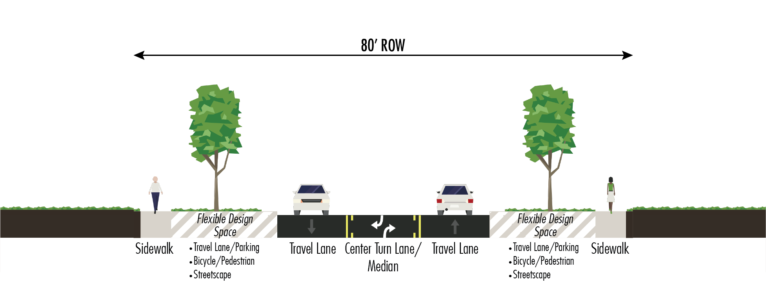

#### Local Connector Street (55.5’ ROW)

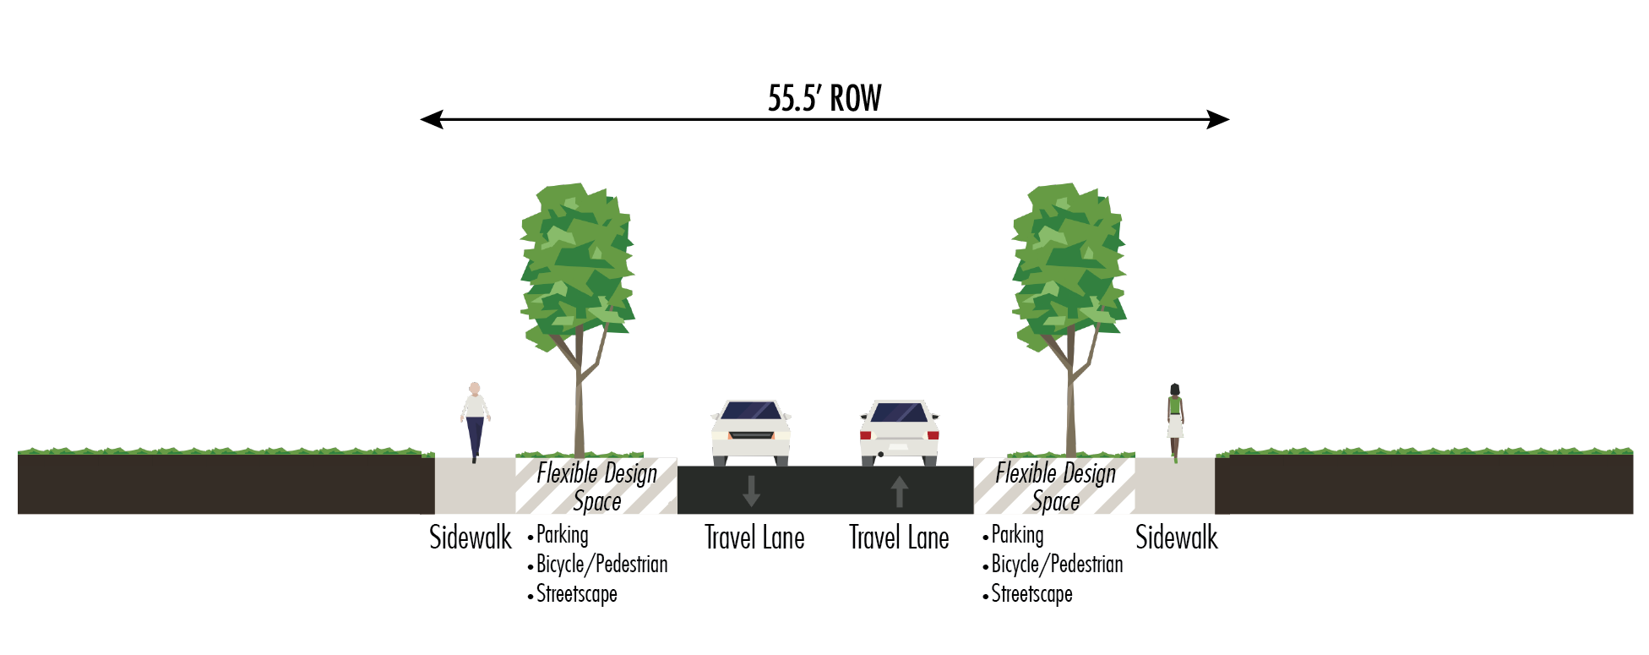

1. **Implementing the Street Network**

This plan serves as the primary tool to enable the City to preserve future corridors and the necessary right-of-way to establish appropriate thoroughfare corridors as development occurs and to improve the existing street system as the need arises. The Transportation Master Plan locates and classifies streets for desired connectivity and capacity for through traffic, access to adjacent land uses, and compatibility with each street’s development character. This plan provides the ability to better integrate networks of other mode choices, including walking, bicycling, and transit. The plan guides future investments and provides the public and the development community with information about the long-term plan for the road network. Simply put, the TMP is the community’s blueprint for a safe, efficient, and sustainable transportation system. It seeks to create and sustain a system that balances local and regional priorities and existing and future conditions, to steer the community toward its vision for the future.

Improvements to Bastrop’s transportation system will include both the construction of new roadways to serve future development, as well as enhancement of existing facilities to further support the mobility and economic vitality of the established community. These improvements are intended to not only provide improved vehicular connectivity as the City grows, but also provide increased options for

alternative modes of transportation. Funding and implementation of the planned street network will require contributions from multiple sources for design, right-of-way acquisition, and construction of various thoroughfare projects. In many cases, new thoroughfare connections and street expansions that the plan anticipates will require right-of-way or easements as part of the development of property. However, the City may need to address priority transportation needs through capital improvement funding or project partnership with regional transportation agencies for funds administered at the county or regional level. The City may also consider alternate funding mechanisms to fund public infrastructure necessitated by new development.